P.R.E.P.
Homeschool instructions:
Your child’s teacher will assign the weeks work,
The Sacrament classes 2 & 8 will be given instructions as what to cover by their teacher. Lessons cannot be accessed online.
Grades K, 1, 3, 4, 5, 6, 7 will work from their book and the Loyola Press Web site parents’ page.
To access the parents page go to
Families | Loyola Press
https://www.loyolapress.com/faith-formation/finding-god/finding-god-2021/parents-and-students/
You will see:
- Home
- Faith Formation
- Finding God
- Finding God 2021
- Families

Families
Finding God offers parents and families materials specifically designed for use at home whether catechesis takes place in the parish, school, or home. From at-home, family friendly lesson plans, to interactive study guides, to the exciting online game Fishers of Faith, the activities listed below will refresh your own faith while helping you become an active partner in your child’s faith formation.
Family Quick Guide: Use this guide to lead children from different grades or studying different chapters through their material at the same time. (English / Spanish)

Additional Resources
Finding God e-newsletters
Looking for family resources for Finding God ©2013? Click here!

Select Grade/Resource
    - Kindergarten
    - Grade 1
    - Grade 2
    - Grade 3
    - Grade 4
    - Grade 5
    - Grade 6
    - Grade 7
    - Grade 8

Click on your grade. Grade 4 is use for this example:
The class is broken down into 5 units and 5 sessions for each unit. Following your teachers email review material first by clicking the unit and reviewing the material for that week, unit 1 pages 1-8 for example

For Grade 4 you will see:
- Home
- Faith Formation
- Finding God
- Finding God 2021
- Families
- Select Grade/Resource
- Grade 4

Finding God: Family Resources: Grades K-8
Select Grade:VIEW

Printer Friendly
Then go to the study guide for each lesion:

Study guide for grade 4 lesion 1
Then click on unit number –At Home Edition

Grade 4 Resources

Together as a Family

At-Home Edition | All Units | Unit 1 | Unit 2 | Unit 3 | Unit 4 | Unit 5
Study Guides | All Units | Unit 1 | Unit 2 | Unit 3 | Unit 4 | Unit 5
With My Family in Spanish |  | Unit 1 | Unit 2 | Unit 3 | Unit 4 | Unit 5
Getting to Know a 4th Grader
Student Glossary in Spanish

Just for Parents
What is STREAM?
Parent Guide to Reading Scripture (English)
Parent Guide to Reading Scripture (Spanish)
Accessing Enhanced Media (English)
Accessing Enhanced Media (Spanish)

Unit 1

Once you have completed the Session click on the Interactive Session Review and email the results to the email supplied by your teacher.
Session | Games
Session 1 | Interactive Session Review
Session 2 | Interactive Session Review
Session 3 | Interactive Session Review
Session 4 | Interactive Session Review
Session 5 | Interactive Session Review
Unit 1 Review | Fishers of Faith

Unit 2
Session | Games
Session 6 | Interactive Session Review
Session 7 | Interactive Session Review
Session 8 | Interactive Session Review
Session 9 | Interactive Session Review
Session 10 | Interactive Session Review
Unit 2 Review | Fishers of Faith

Unit 3
Session | Games
Session 11 | Interactive Session Review
Session 12 | Interactive Session Review
Session 13 | Interactive Session Review
Session 14 | Interactive Session Review
Session 15 | Interactive Session Review
Unit 3 Review | Fishers of Faith

Unit 4
Session | Games
Session 16 | Interactive Session Review
Session 17 | Interactive Session Review
Session 18 | Interactive Session Review
Session 19 | Interactive Session Review
Session 20 | Interactive Session Review
Unit 4 Review | Fishers of Faith

Unit 5
Session | Games
Session 21 | Interactive Session Review
Session 22 | Interactive Session Review
Session 23 | Interactive Session Review
Session 24 | Interactive Session Review
Session 25 | Interactive Session Review
Unit 5 Review | Fishers of Faith

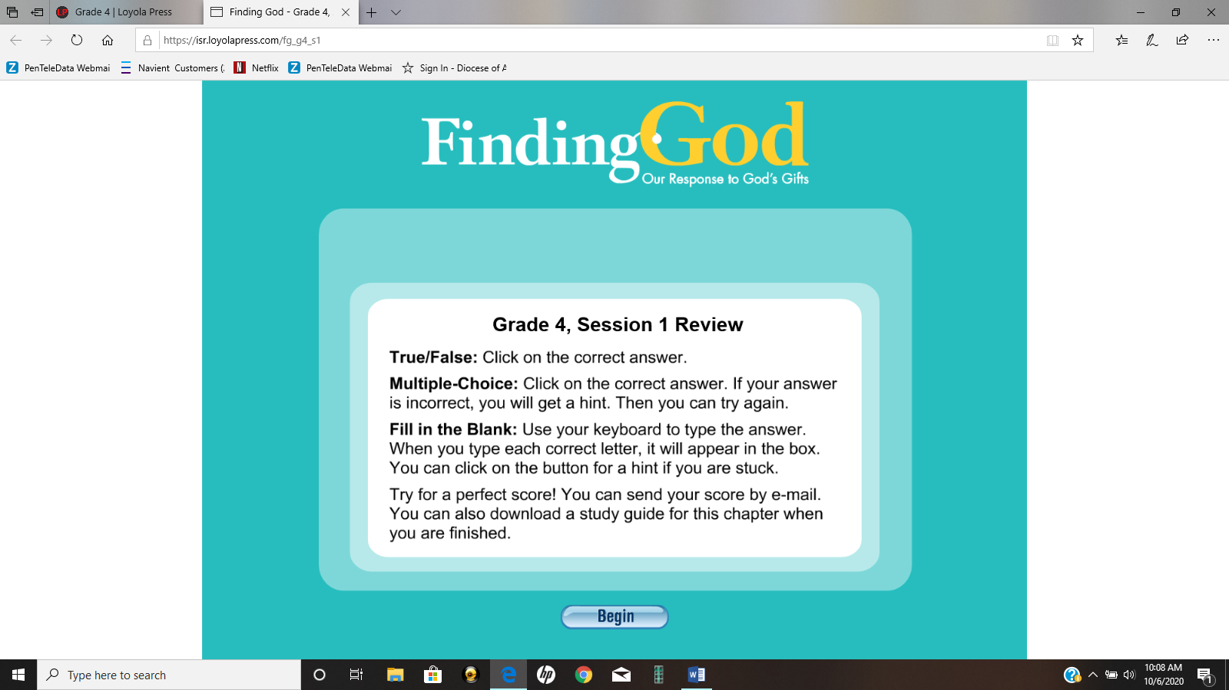

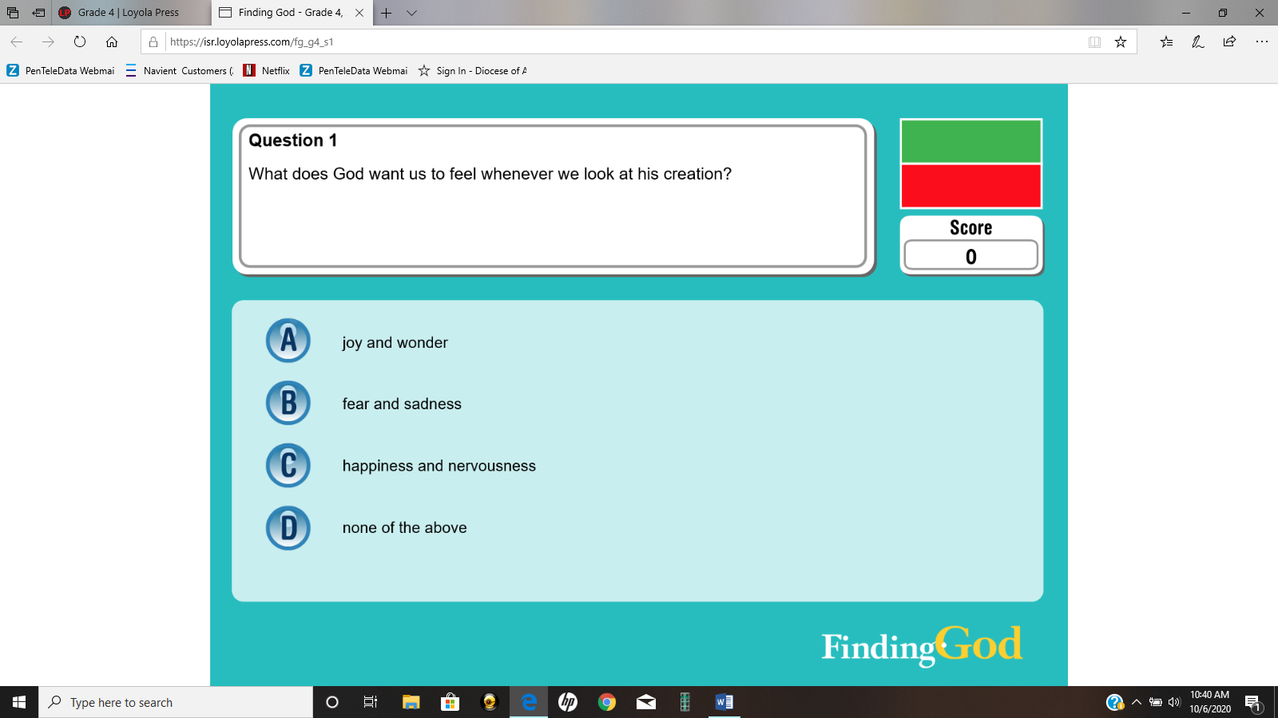
After you have answered the questions you will see the following:

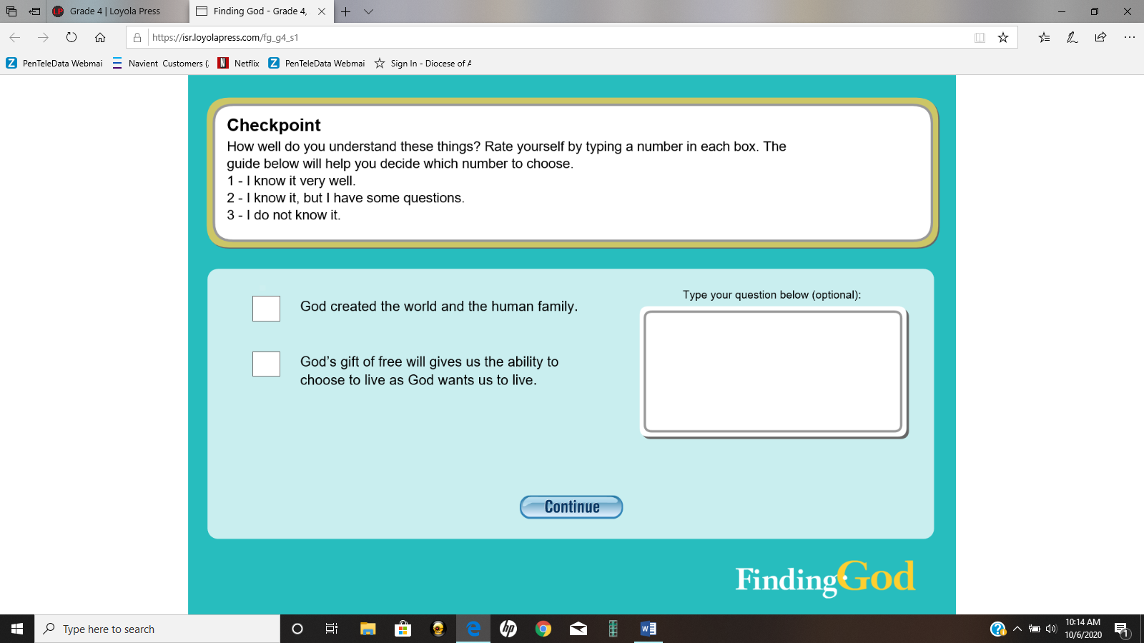
Please add comments or questions
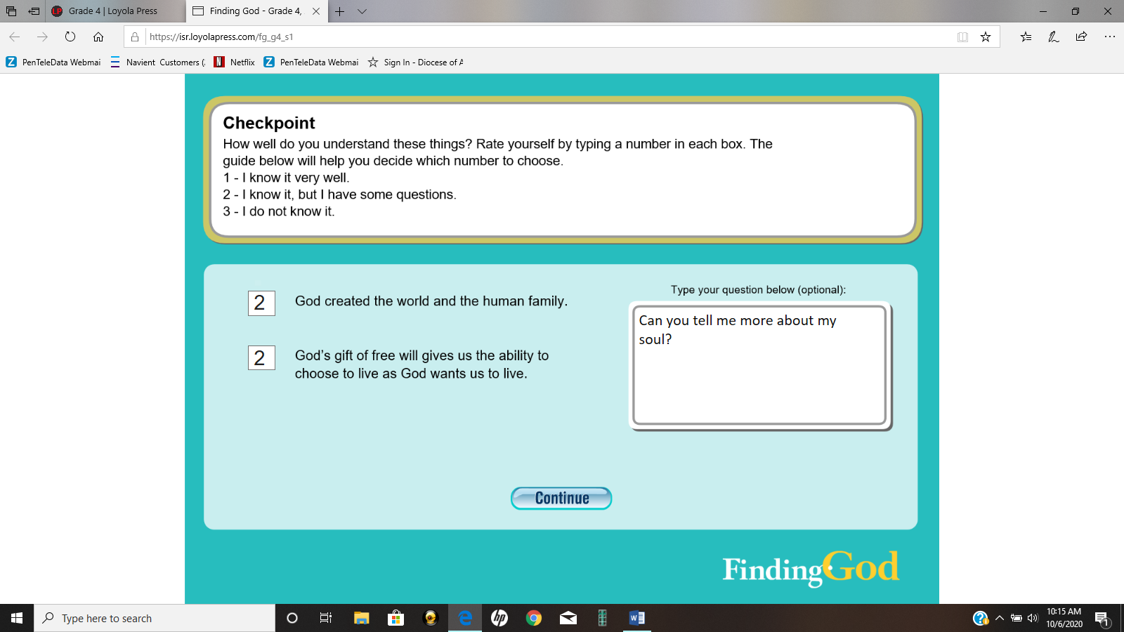

email to your teacher
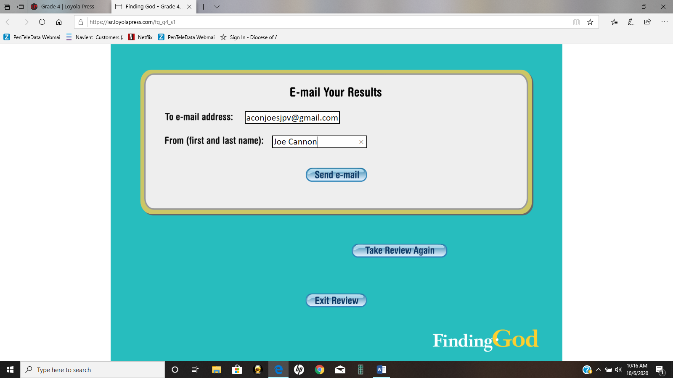

Check out the raising faith filled page for each lesson

